GRAPHIC | ENGLISH | SPANISH
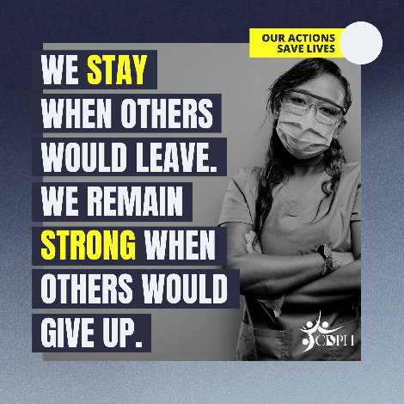 | Being a health care worker isn’t just a job – it’s a way of life. We remain strong when others would give up. We hold it together when others might fall apart. #COVID19 doesn’t take time off and neither do we. We lead by example at home and at work. #OurActionsSaveLives | Ser un trabajador de la salud no es solo un trabajo, es una forma de vida. Seguimos fuertes cuando otros se rinden. Nos mantenemos unidos mientras otros pueden desmoronarse. #COVID19 no descansa y nosotros tampoco. Incluso nuestras acciones en casa marcan una gran diferencia. #NuestrasAccionesSalvanVidas
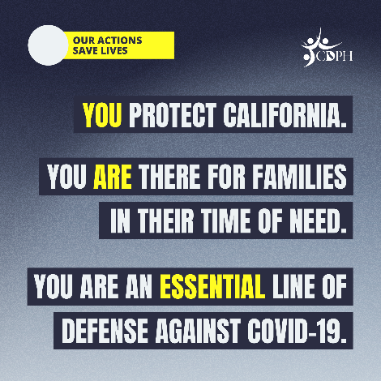 | To those on the front lines of #COVID19, thank you for all you’re doing to keep #CA safe. That work continues at home. The little things you do - whether at work or home - wearing a mask, avoiding gatherings, staying 6 feet apart, washing your hands - make a big difference. | A los que están en la primera línea de #COVID19, gracias por todo lo que están haciendo para mantener segura a #California. Ese trabajo continúa en casa. Las pequeñas cosas que hacemos (usar una mascarilla, evitar reuniones, mantener distancia de 6 pies, lavarse las manos) marcan una gran diferencia. #NuestrasAccionesSalvanVidas
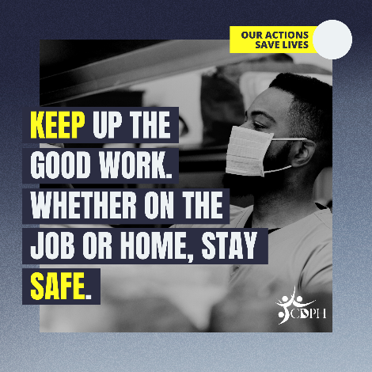 | You may never know the full impact of your actions, but it’s undeniable your actions have saved lives. To those on the front lines of #COVID19, stay strong. Even when not at work, keep wearing a mask, avoid gatherings, stay 6 feet apart, and wash your hands. #OurActionsSaveLives | Es posible que nunca sepamos el impacto total de nuestras acciones, pero es innegable que tus acciones han salvado vidas. Para aquellos en la primera línea de #COVID19, manténganse fuertes. Sigan usando mascarilla, eviten las reuniones, manténgase a 6 pies de distancia y lávense las manos. #NuestrasAccionesSalvanVidas
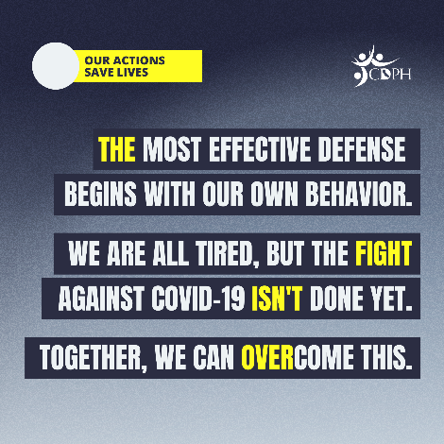 | Our work is not finished even when we go home. Our residents, our team members and our families depend upon each of us. Stay strong. Stay the course. #OurActionsSaveLives
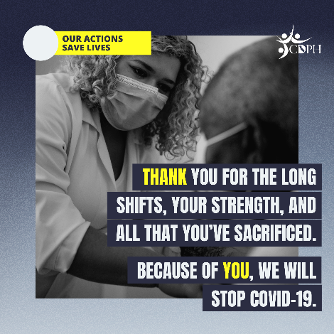 | Keep protecting us from #COVID19 both at home and work. The health of your patients, families and coworkers depend on your personal actions, both on and off the job and we thank you for your service to the people of #California.
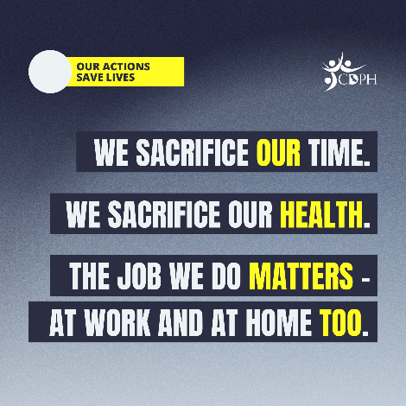 | Remember—you are not alone. You cannot care for your residents or your family or continue your critical work if you do not take care of yourself. You are essential to the people of #California.
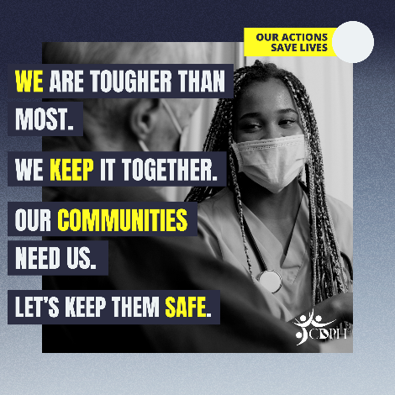 | To slow the spread of #COVID19, each of us must continue to take personal responsibility to protect ourselves and our loved ones, regardless of where we are. By doing just a few simple things, we can make a big difference. #OurActionsSaveLives
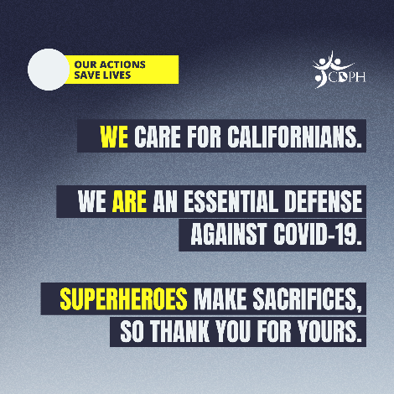 | There is power in prevention, both on and off the job. The mask you wear, the distance you keep from others, the handwashing that you practice each day makes a difference. You will never know the full impact of your actions, but it is undeniable that your actions have saved lives. Stay strong! #OurActionsSaveLives

